**Lab Tutorial**

**Class 7**

**Lab 1: Basic Programming**

1. Question-Answer: Fill the box

a.

var price1 = 300;  
var price2 = 430;

var total = price1 + price2;

total =

b.

var price1 = 45.50;

var price1 = 78.40;  
var price2 = 117.30;

var total = price1 + price2;

total =

c.

var salary = 42000;  
var cost= 30500;

var total = salary - cost;

total =

d.

var x = 900;  
var y = 430;

var total = x + 100;

total =

1. Question-Answer: Fill the box
2. Example of

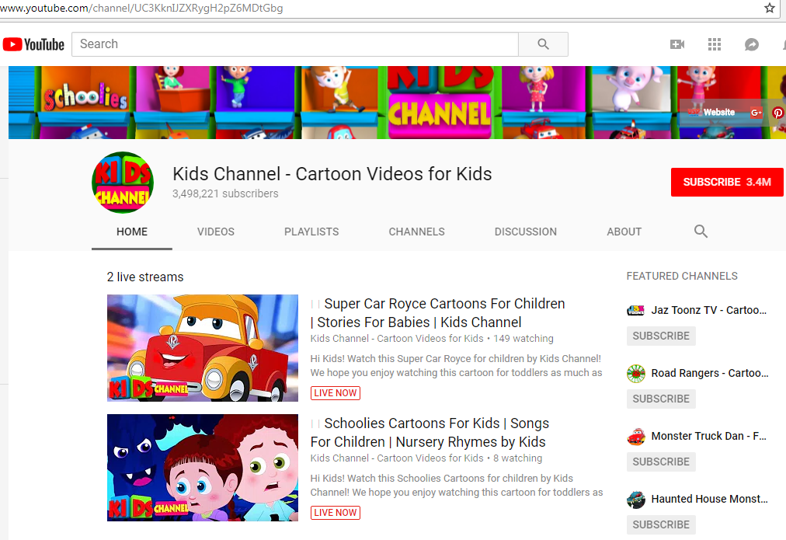

1. Example of

